Test Bank

for

Corporate Finance

Fourth Edition

Jonathan Berk
Stanford University

Peter DeMarzo
Stanford University

Test Bank
by
Janet Payne
Texas State University

&

William Chittenden
Texas State University

Copyright 2017. All Rights Reserved.

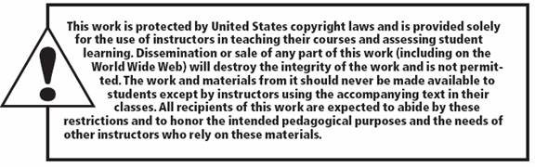

Vice President, Business Publishing: Donna Battista
Editor-in-Chief: Adrienne D’Ambrosio
Acquisitions Editor: Kate Fernandes
Editorial Assistant: Kathryn Brightney
Team Lead, Program Management: Ashley Santora
Program Manager: Nancy Freihofer
Team Lead, Project Management: Jeff Holcomb
Project Manager: Meredith Gertz
Operations Specialist: Carol Melville

Copyright © 2017, 2014, 2011 Pearson Education, Inc. All rights reserved. Manufactured in the United States of
America. This publication is protected by copyright, and permission should be obtained from the publisher prior to any prohibited reproduction, storage in a retrieval system, or transmission in any form or by any means, electronic, mechanical, photocopying, recording, or otherwise. For information regarding permissions, request forms, and the appropriate contacts within the Pearson Education Global Rights and Permissions department, please visit www.pearsoned.com/permissions/.

PEARSON, ALWAYS LEARNING, and MYFINANCELABTM are exclusive trademarks owned by Pearson Education, Inc. or its affiliates in the U.S. and/or other countries. Unless otherwise indicated herein, any third-party trademarks, logos, or icons that may appear in this work are the property of their respective owners, and any references to third-party trademarks, logos, icons, or other trade dress are for demonstrative or descriptive purposes only. Such references are not intended to imply any sponsorship, endorsement, authorization, or promotion of Pearson’s products by the owners of such marks, or any relationship between the owner and Pearson Education, Inc., or its affiliates, authors, licensees, or distributors.



ISBN-13: 978-0-13-410149-1
ISBN-10: 0-13-410149-9

